DIP Assignment-3

Author : Rohan G. Shah

M.Tech AI (SR. no. 19243)

Date :25/10/2021

Q1) (A) DFT of image :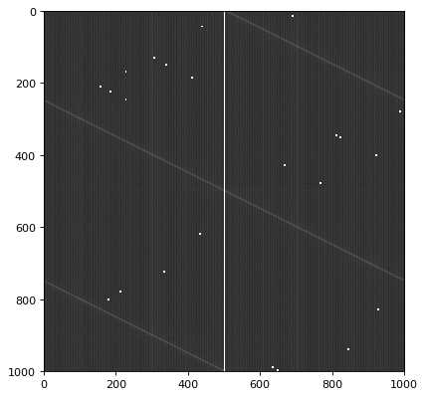

(B) After doing inverse DFT of the filtered(ILPF) image we get ringing effect on our output. 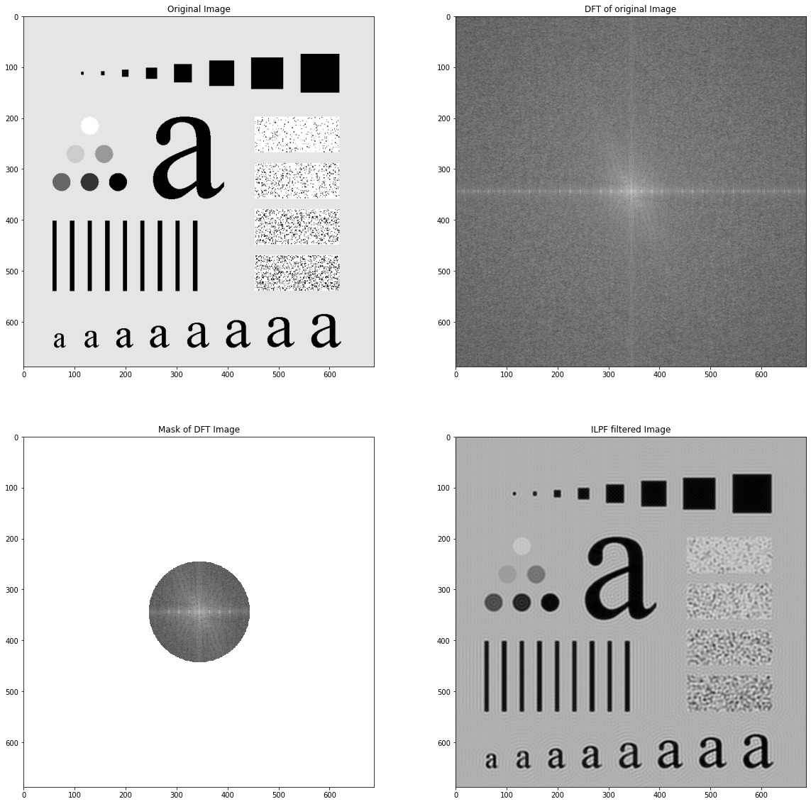

(C)Using Gaussian filter we get rid of the ringing effect in output and get a smoother image than ILPF.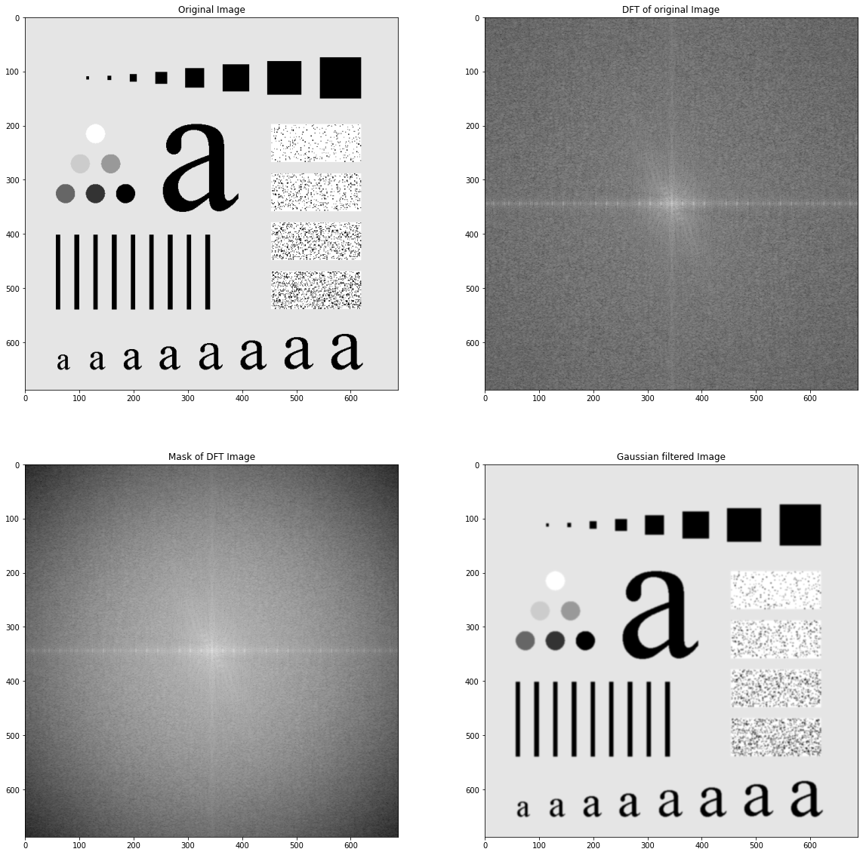

2)(A)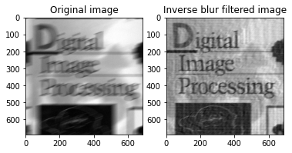

(B)Output after applying Wiener filter deblur image and edge preserved.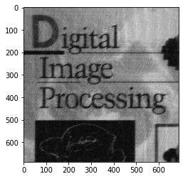

3) (A)Mean Filter on noisy_book1.png gives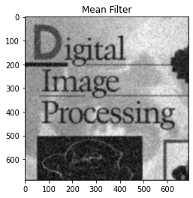

Median Filter on noist_book1.png gives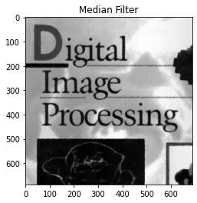

(B)Gaussian smoothing 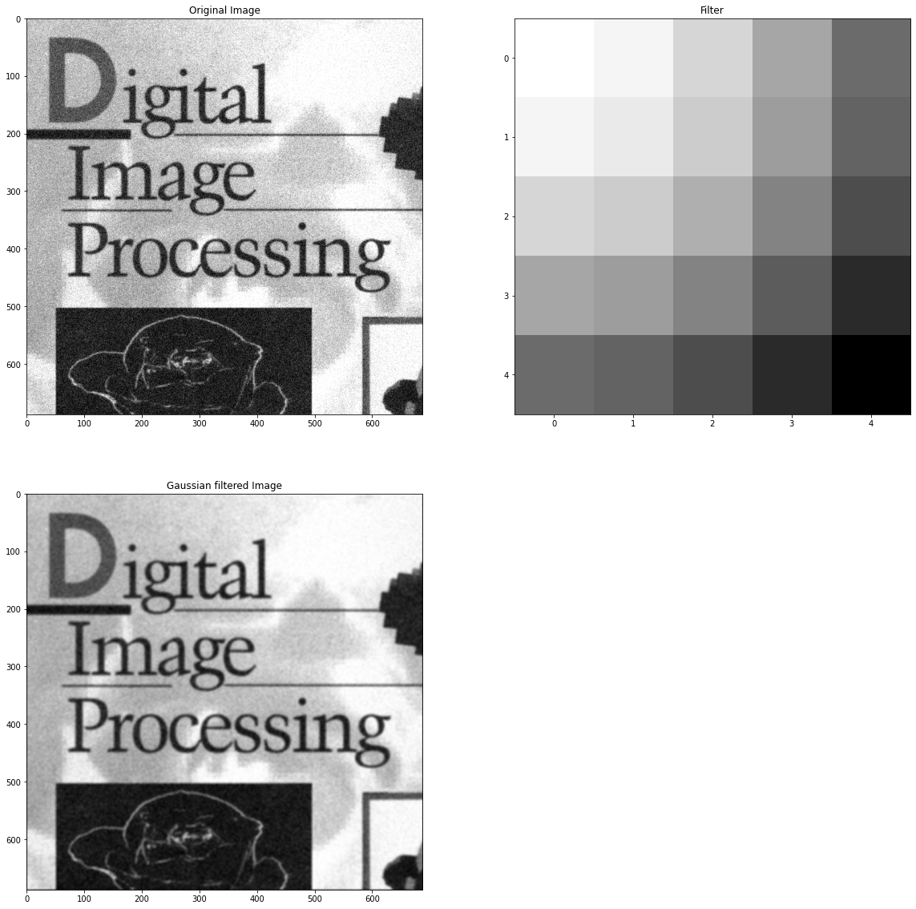

Bilateral Smoothing gives output image as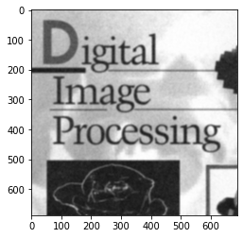Nearly same as gaussian smoothing.

4)(A)K =0.015816737080205662 (B)k=-0.07677586043852624